Functional Requirement Document for Car Wash Services

**Submitted to**

**Cognizant Technology Solutions**

**Submitted by**

Sanjeev S (896455)

Arthi A (2063544)

Arthi K (2063220)

Chandhu M U (2063252)

Bharanidharan K (2063488)

**For more information, please visit on website:**

<https://www>.justdial.com

**Date of Submission**

January 2022

**Functional Specifications Document Authorization Memorandum**

I have carefully assessed the Functional Specifications Document for the

<PROJECT NAME>

MANAGEMENT CERTIFICATION – Please check the appropriate statement

________ the document is accepted.

_________ the document is accepted pending the changes noted.

_________ the document is not accepted.

We fully accept the changes as needed improvements and authorize initiation

Of work to proceed. Based on our authority and judgement, the continued.

Operation of this system is authorized.

_________________________

_______________

NAME DATE

Project Manager

____________________

______________

NAME DATE

Director

TABLE OF CONTENTS

1.0 INTRODUCTION 4

1.1 Purpose 4

1.2 Abbreviations and Acronyms 4

1.3 Document conventions 4

2.0 GENERAL DESCRIPTION 5

2.1 Product Context 5

2.2 Overview of Functional Requirements 6

2.3 Overview of Data Requirements 6

2.4 Operating Environment 7

2.5 General Constraints, Assumptions, Dependencies, Guidelines 7

2.6 Design and Implementation Constraints 7

3.0 REQUIREMENTS 8

3.1 External Interface Requirements 8

3.1.1 User Interfaces 8

3.1.2 Hardware Interfaces 8

3.1.3 Software Interfaces 8

3.1.4 Communications Interfaces 9

3.2 Functional Requirements 9

3.2.1 Template for functional requirements 9

3.3 Performance Requirements 15

3.4 Security 15

3.5 Usability 15

3.6 Other Requirements 15

Appendix A. Analysis Models 17

Appendix B. Issues List 21

**1.0. INTRODUCTION**

## 1.1. Purpose

Justdial is an Indian internet technology company that provides local search for different services in India over the phone, website and mobile apps. It is founded in 1996 by VSS Mani, the company is headquartered in Mumbai, India.

**1.2. Abbreviations and Acronyms**

* HTML - Hyper Text Markup Language
* CSS -Cascading Style Sheets
* RAM - Random Access Memory.
* GB - Giga Bytes.
* HTTP – Hyper Text Transfer Protocol

**1.3. References**

<https://www.guru99.com/functional-requirement->

specification- example.html

**1.4. Document conventions**

Bold faced text has been used to emphasise headings

and subheadings. Arial font has been used with headings of size 16 and subheadings of size 14 and the description with12.

# 2.0. GENERAL DESCRIPTION

## 2.1. Product Context

Justdial Website’s main function is to provide fast, free, reliable, and comprehensive information to our users and enable discovery and transactions for all products and services. Clients can find reviews for respective products and services.

## 2.2. Overview of Functional Requirements

1. Click Auto Care
2. Click Car Wash
3. Select Location
4. Click Free Listing
5. Enter the details of functionalities
6. Click Fitness
7. Click Gym

**2.3. Overview of Data Requirements**

* **Input value**: input data should be from dissimilar sources.
* **Static value**: a static application or system is required for automation.
* **Output**: expected output data is preferred.

**2.4. Operating Environment**

* **Processor**: Intel core
* **RAM:** 4 GB
* **OS**: windows 8

## 2.5. Design and Implementation Constraints

* The application has used HTML, CSS, and java script as main technologies.
* HTTP protocols are used to access the web application.
* Since Justdial is a web-based application, internet connection must be established.
* This web application runs on different browsers.

## 2.6. User Documentation

There are no user manuals, online helps as it is easily understood.

# 3.0. REQUIREMENTS

## 3.1. External Interface Requirements

## 3.1.1. User Interfaces

* All users will see the same page when they enter in this web site.
* The user interface is simple and easy to understand the terminology.

### 3.1.2. Hardware Interfaces

* No extra hardware interfaces are needed.
* The system will use standard hardware and data communication resources.

### 3.1.3. Software Interfaces

* **OS**: windows 8
* **Web browser**: The system is a web-based application; clients need any web browser such as chrome, Firefox, opera, internet explorer. The computer must have an internet connection to access with the system.

### 3.1.4. Communications Interfaces

* This system uses communication resources which includes HTTP protocol for communication with web bro and TCP/IP network protocol with HTTP protocol.

## 3.2. Functional Requirements

## 3.2.1. Template for functional requirements

1. **Click Auto Care**
2. **Input:** Click Auto Care
3. **Output:** The Auto Care details is displayed.

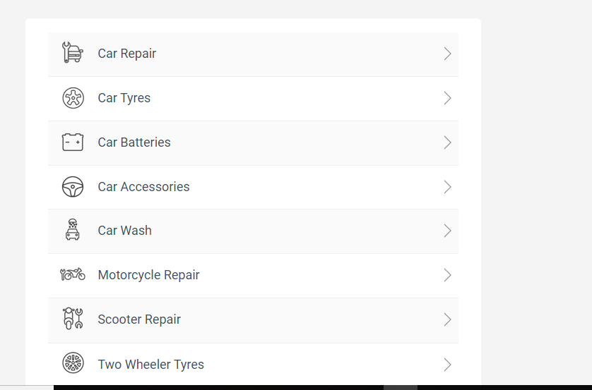

1. **Click Car Wash**
2. **Input:** Click Car Wash
3. **Output:** Car Wash details is displayed.

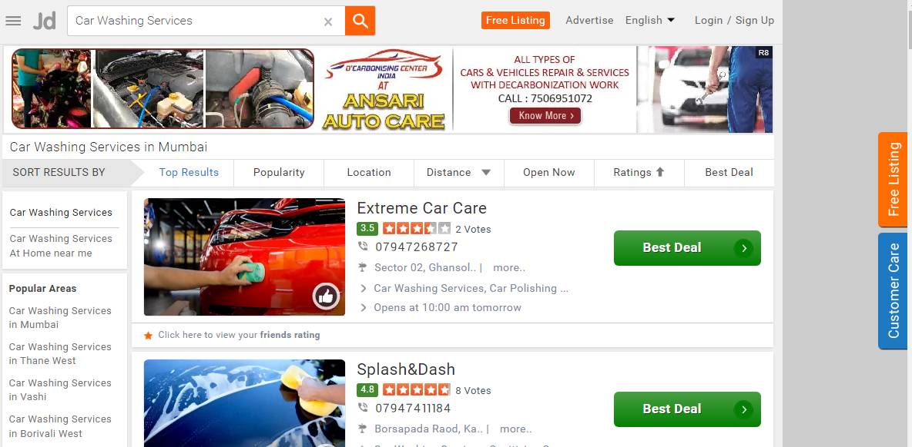

**c. Selecting Location:**

**ⅰ. Input:** Selecting the location nearest our location

**ⅱ. Output:** The results are displayed

**d. Click Free listing:**

1. **Input:** Click the free Listing button
2. **Output:** The free listing page is displayed

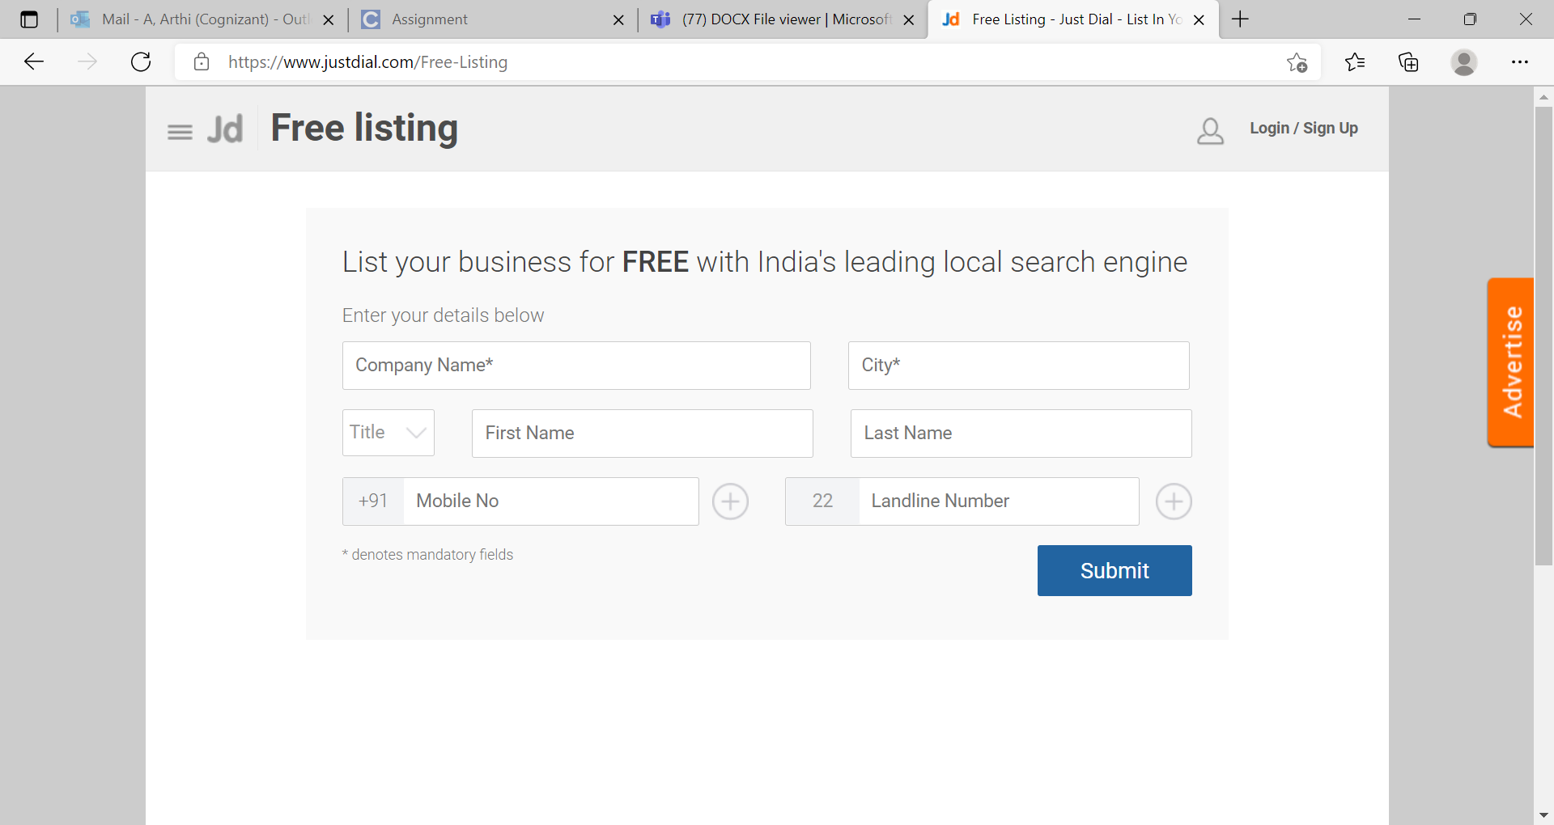

**e. Enter the details of functionalities:**

**I. Input:** Enter the valid details in the free listing page

**ii. Output:** The details are displayed.

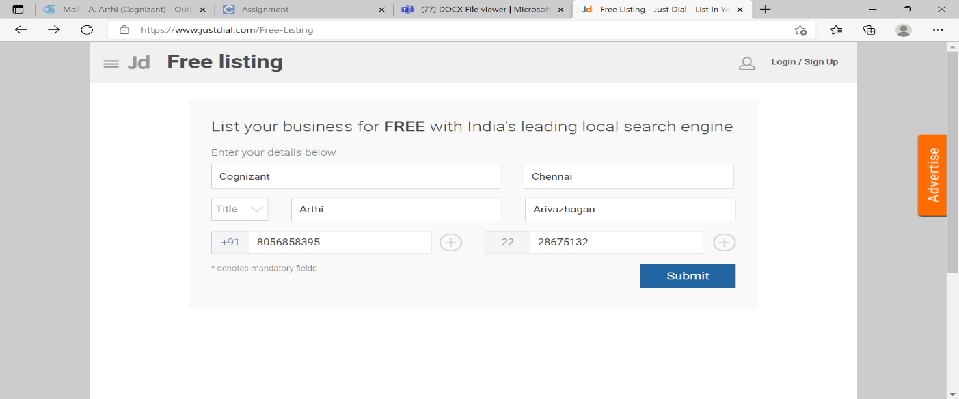

**f. Click Fitness**

**ⅰ. Input:** Click the Fitness Button

**ⅱ. Output:** The Fitness page is displayed

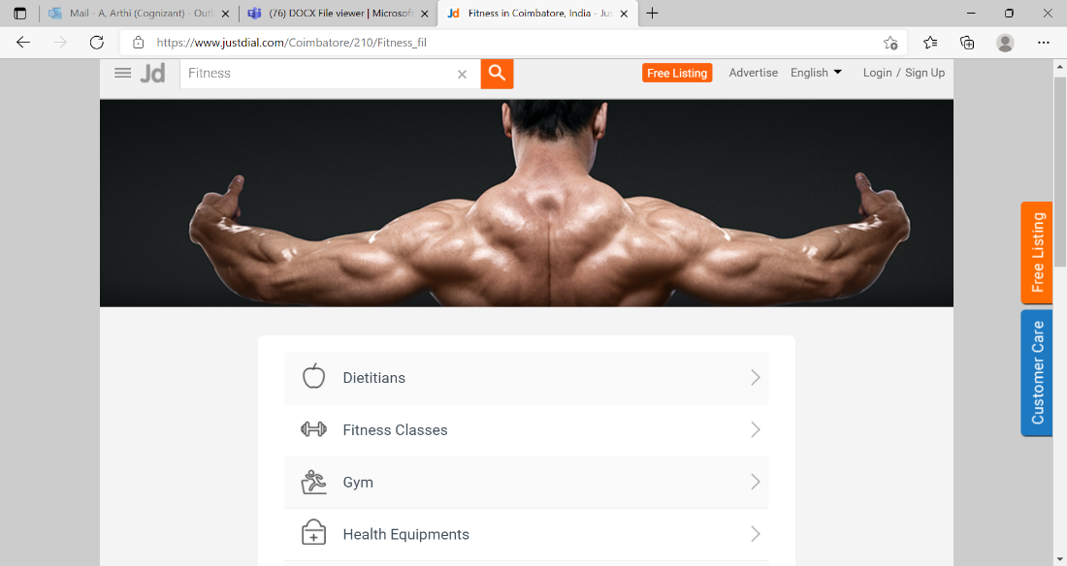

**g. Click Gym**

i. Input: click the gym button

ii. Output: The list is displayed Successfully

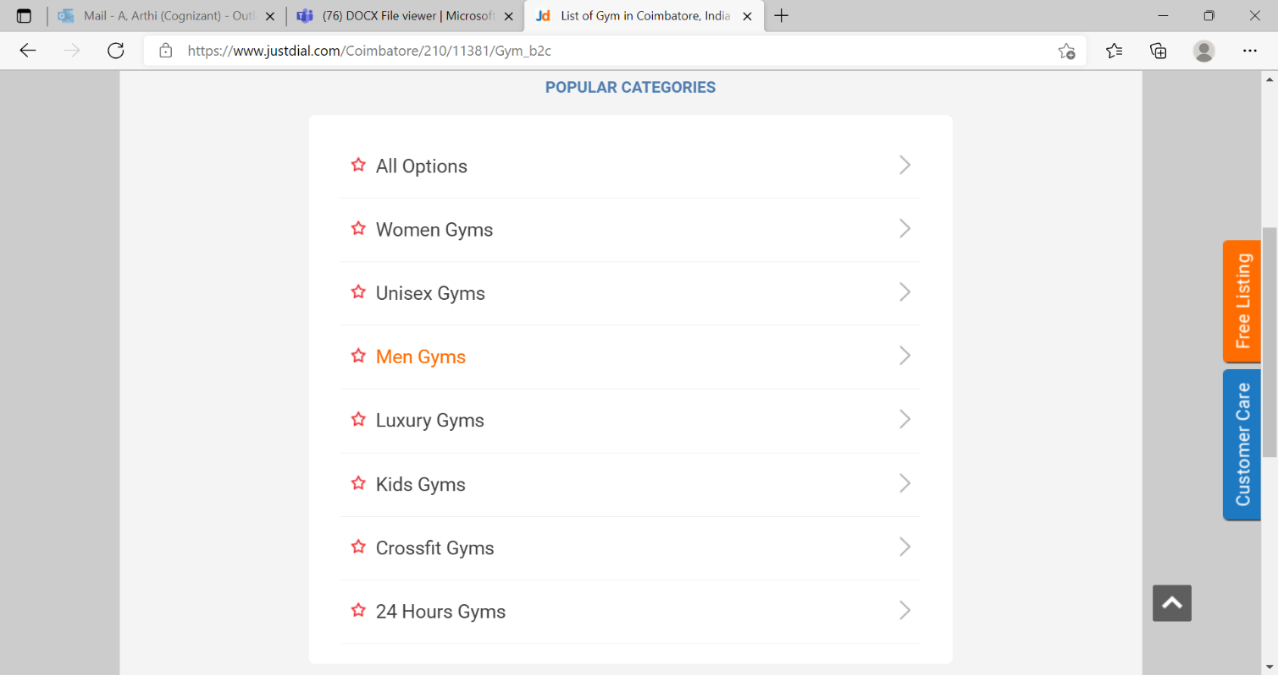

**3.3 Performance Requirements**

The System response time for every interaction conducted by the user should not exceed more than a minimum of 10 seconds. The system should provide a high-performance rate when executing users input and should be able to provide response within a short time span, usually 50 seconds for a complicated task and 20-25 seconds for a less complicated task.

**3.4 Usability**

The System provides several options which are very easy to use. Terminology is easy so, we can interact with the application very easily.

**3.5 Other Requirements**

**a. Availability:**

The System should be available for access at 24 hours,7days a week.Also in the Occurrence of any major system malfunctioning, the system should be available in 1 to 2 working days, so that business process is not severely affected.

**b. Error handling:**

Error should be considerably minimized and an appropriate error message that guides the user to recover from the error should be provided. Validation of user’s message is highly essential.

**Appendix A. Analysis Models**

List any attached/referenced documentation such as data flow diagrams, class diagrams, state-transition diagrams, entity-relationship diagrams, etc.

|  |  |  |
| --- | --- | --- |
| **ANALYSIS MODELS** | | |
| **DOCUMENT NAME** | **DESCRIPTION** | **LOCATION** |
| FUNCTIONAL REQUIREMENT DOCUMENT | CAR WASH SERVICES | JUSTDIAL.COM |
| FREE LISTING |
| FITNESS |

**DATA FLOW DIAGRAM**

1. **Data Flow for car wash services**

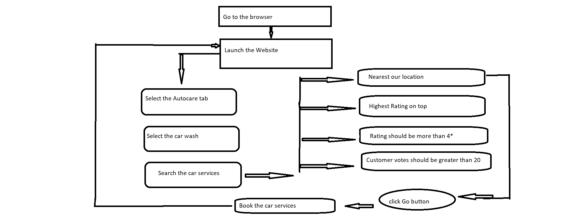

**2.Data Flow for Free listing**

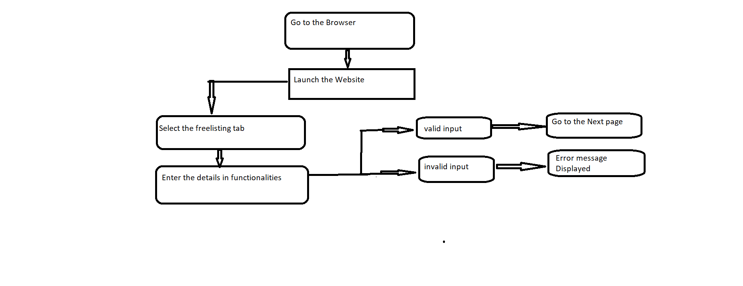**3.Data Flow for Fitness**

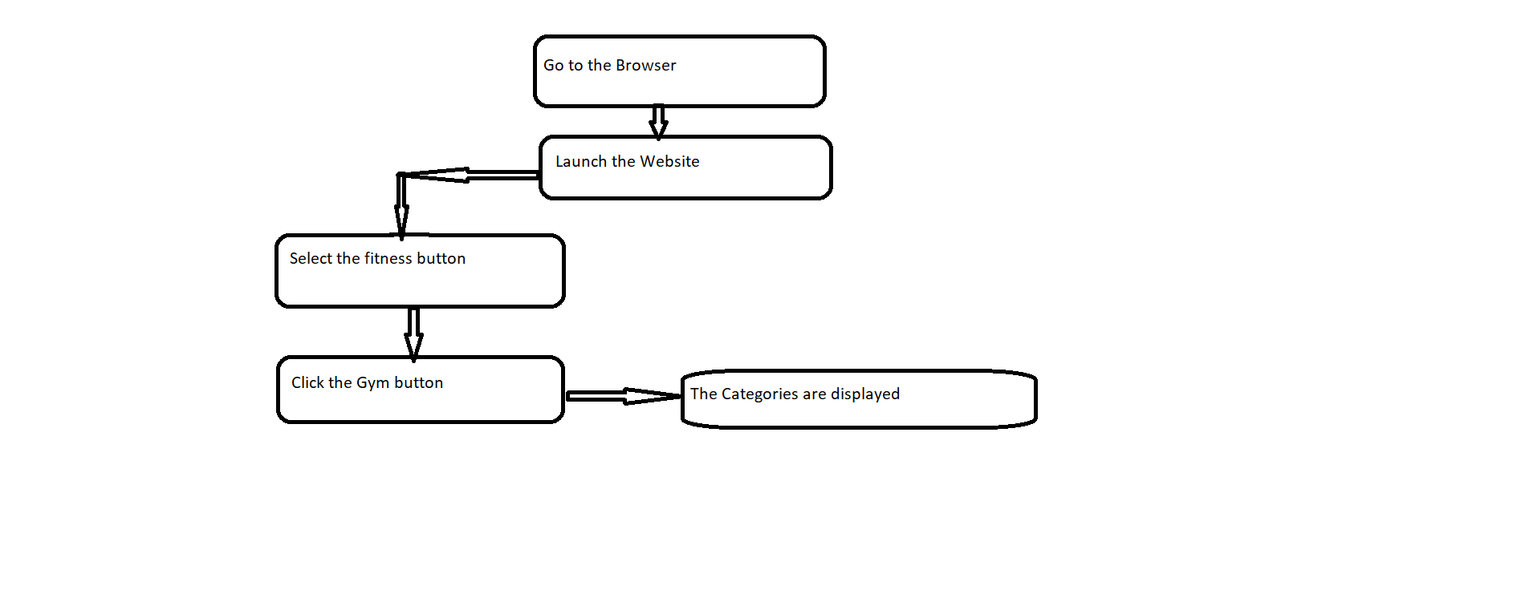

**Appendix B. Issues List**

|  |  |  |
| --- | --- | --- |
| **ISSUES LIST** | | |
| **ISSUE ID** | **ISSUE DESCRIPTION** | **STATUS** |
| IS_1 | Defect in the Justdial website, couldn’t inspect the mobile number for car wash service shop names. | Pending |